Cleaning US Census Data
R tidyverse data-cleaning pipeline (readr + dplyr + tidyr) for multi-file census extracts
Problem Statement
The Census Bureau received 10 overlapping CSV extracts (states_0.csv … states_9.csv) containing state-level demographics, race percentages (with % symbols), median income (with $), and a combined GenderPop field (e.g. 2341093M_2489527F). Prior analysts manually browsed files and copy-pasted into Excel—an unscalable, error-prone process. The task is to produce a single, analysis-ready data frame of 52 unique states/territories with numeric columns, decimal race shares, and no duplicates so that income, diversity, and gender-balance questions can be answered immediately.
Solution Strategy
1) Discover files with list.files(pattern) → lapply(read_csv) → bind_rows. 2) Diagnose with colnames/str/head; drop the meaningless index column. 3) String-clean race % and Income $ via gsub, then cast to numeric. 4) separate() GenderPop on “_”, strip M/F, convert. 5) Scale race percentages to [0,1]. 6) Detect and remove exact duplicate rows with distinct(). 7) Validate final shape (52 × 11) and begin exploratory analysis. Alternate base-R paths (lapply + do.call(rbind), substr, as.numeric) are provided for environments without tidyverse.
Solution
After the pipeline the clean data set contains 52 rows (50 states + DC + Puerto Rico). Mean median household income ≈ $55,977 (range $20.7k–$78.8k). Average White share ≈ 67.6 %. Female population share clusters tightly around 50–52 %. Nine exact duplicate rows (the overlapping state records across files) were removed. The cleaned frame is ready for regression, choropleth mapping, or disparity analysis.
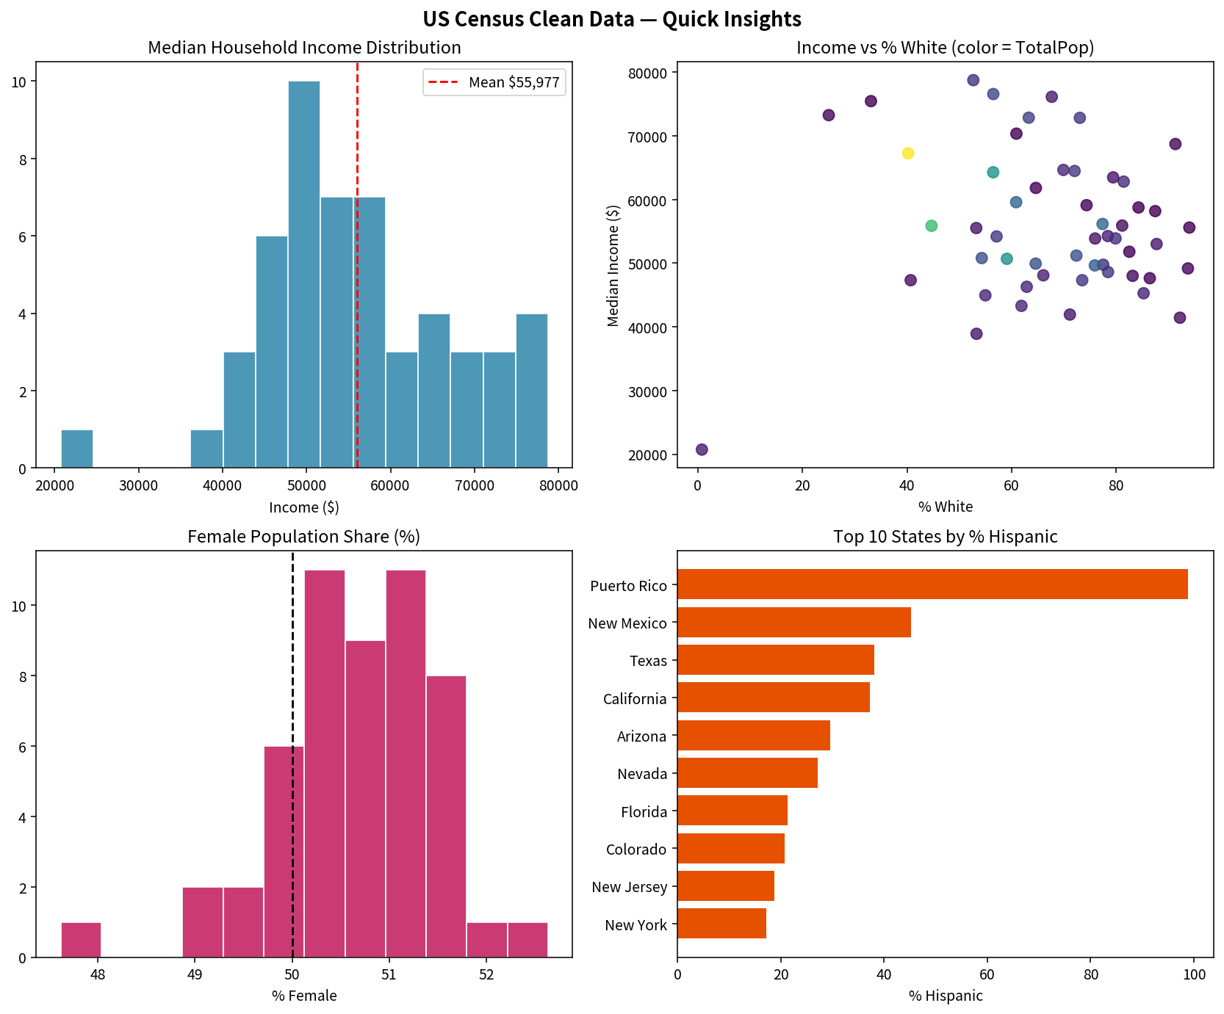
Key Takeaways
• Multi-file census extracts are the norm; list.files + lapply + bind_rows is the scalable pattern.
• Symbols (%, $) and concatenated fields (GenderPop) must be cleaned before any numeric analysis.
• Overlapping files produce exact duplicates—always run duplicated() / distinct() before modeling.
• Converting percentages to decimals early simplifies later calculations and model coefficients.
• The same tidyverse pipeline generalizes to any multi-file survey, administrative, or sensor extract.

